IMPLEMENTATION
MODULES:
- Dataset
- Importing the necessary libraries
- Retrieving the images
- Model Selection
- Saving the Trained Model
- The creation Of the face database
- The process of attendance taking
- Step For Working

MODULES DESCSRIPTION:

Dataset:
In the first module, we develop the system to get the input dataset for using webcam (VideoCapture object to access WebCam) and create own dataset.

Importing the necessary libraries:
We will be using Python language for this. First we will import the necessary libraries such as pandas, numpy, matplotlib and scikit-learn.

Retrieving the images:
In this module we will retrieve the images from the dataset and convert them into a format that can be used for training and testing the model. This involves reading the images, resizing them, and normalizing the pixel values. We will retrieve the images and their labels. Then resize the images to (50,50) as all images should have same size for recognition. Then convert the images into numpy array.

Model Selection:
We used KNeighbors Classifier machine learning algorithm.

KNeighborsClassifier Algorithm:
The K-nearest Neighbors (KNN) algorithm is a type of supervised machine learning algorithm used for classification, regression as well as outlier detection. It is extremely easy to implement in its most basic form but can perform fairly complex tasks. It is a lazy learning algorithm since it doesn't have a specialized training phase. Rather, it uses all of the data for training while classifying (or regressing) a new data point or instance.
KNN is a non-parametric learning algorithm, which means that it doesn't assume anything about the underlying data. This is an extremely useful feature since most of the real-world data doesn't really follow any theoretical assumption e.g. linear separability, uniform distribution, etc.

When Should You Use KNN?
Suppose you wanted to rent an apartment and recently found out your friend's neighbor might put her apartment up for rent in 2 weeks. Since the apartment isn't on a rental website yet, how could you try to estimate its rental value?
Let's say your friend pays $1,200 in rent. Your rent value might be around that number, but the apartments aren't exactly the same (orientation, area, furniture quality, etc.), so, it would be nice to have more data on other apartments.

By asking other neighbors and looking at the apartments from the same building that were listed on a rental website, the closest three neighboring apartment rents are $1,200, $1,210, $1,210, and $1,215. Those apartments are on the same block and floor as your friend's apartment.
Other apartments that are further away, on the same floor, but in a different block have rents of $1,400, $1,430, $1,500, and $1,470. It seems they are more expensive due to having more light from the sun in the evening.
Considering the apartment's proximity, it seems your estimated rent would be around $1,210. That is the general idea of what the K-Nearest Neighbors (KNN) algorithm does! It classifies or regresses new data based on its proximity to already existing data.

Translate the Example into Theory
When the estimated value is a continuous number, such as the rent value, KNN is used for regression. But we could also divide apartments into categories based on the minimum and maximum rent, for instance. When the value is discrete, making it a category, KNN is used for classification.
There is also the possibility of estimating which neighbors are so different from others that they will probably stop paying rent. This is the same as detecting which data points are so far away that they don't fit into any value or category, when that happens, KNN is used for outlier detection.

In our example, we also already knew the rents of each apartment, which means our data was labeled. KNN uses previously labeled data, which makes it a supervised learning algorithm.
KNN is extremely easy to implement in its most basic form, and yet performs quite complex classification, regression, or outlier detection tasks.
Each time there is a new point added to the data, KNN uses just one part of the data for deciding the value (regression) or class (classification) of that added point. Since it doesn't have to look at all the points again, this makes it a lazy learning algorithm.
KNN also doesn't assume anything about the underlying data characteristics, it doesn't expect the data to fit into some type of distribution, such as uniform, or to be linearly separable. This means it is a non-parametric learning algorithm. This is an extremely useful feature since most of the real-world data doesn't really follow any theoretical assumption.

Visualizing Different Uses of the KNN
As it has been shown, the intuition behind the KNN algorithm is one of the most direct of all the supervised machine learning algorithms. The algorithm first calculates the distance of a new data point to all other training data points.
After calculating the distance, KNN selects a number of nearest data points - 2, 3, 10, or really, any integer. This number of points (2, 3, 10, etc.) is the K in K-Nearest Neighbors!
In the final step, if it is a regression task, KNN will calculate the average weighted sum of the K-nearest points for the prediction. If it is a classification task, the new data point will be assigned to the class to which the majority of the selected K-nearest points belong.
Let's visualize the algorithm in action with the help of a simple example. Consider a dataset with two variables and a K of 3.
When performing regression, the task is to find the value of a new data point, based on the average weighted sum of the 3 nearest points.
KNN with K = 3, when used for regression:
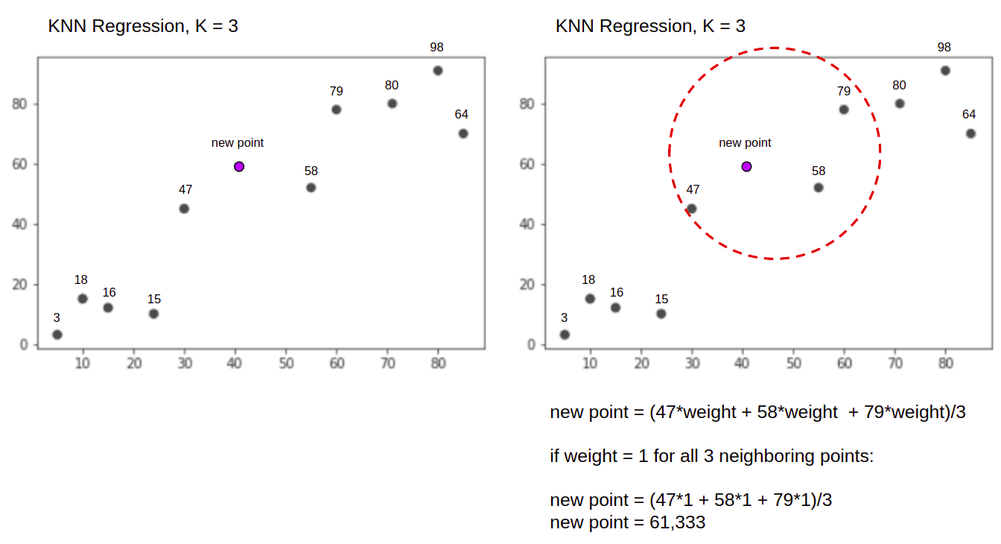

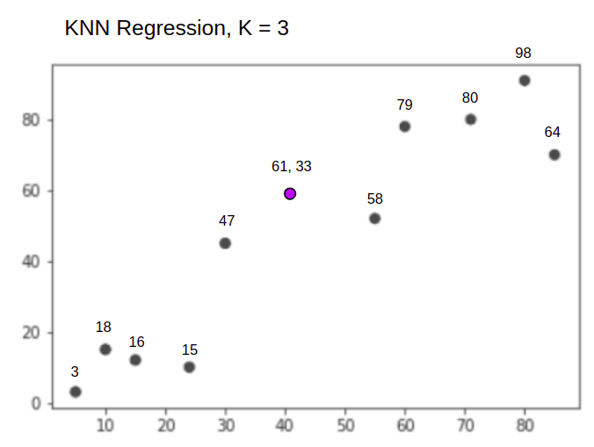
The KNN algorithm will start by calculating the distance of the new point from all the points. It then finds the 3 points with the least distance to the new point. This is shown in the second figure above, in which the three nearest points, 47, 58, and 79 have been encircled. After that, it calculates the weighted sum of 47, 58 and 79 - in this case the weights are equal to 1 - we are considering all points as equals, but we could also assign different weights based on distance. After calculating the weighted sum, the new point value is 61,33.
And when performing a classification, the KNN task is to classify a new data point, into the "Purple" or "Red" class.
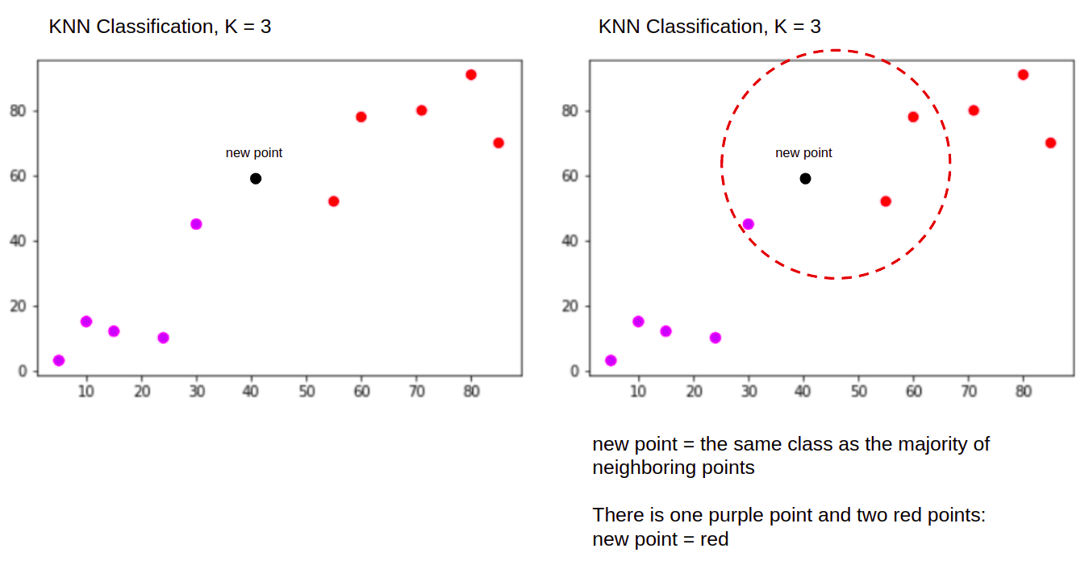
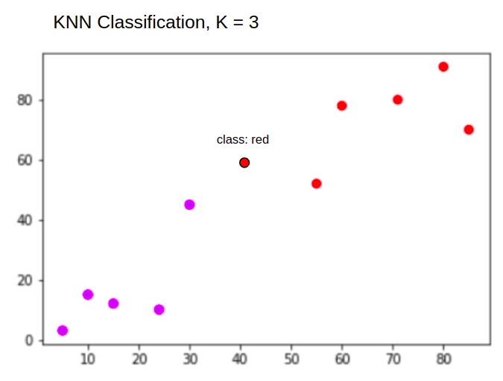

Saving the Trained Model:
Once you’re confident enough to take your trained and tested model into the production-ready environment, the first step is to save it into a .h5 or .pkl file using a library like pickle .
Make sure you have pickle installed in your environment.
Next, let’s import the module and dump the model into.pkl file

The creation of the face database:
The face database is an important step to be done before any further process can be initiated. This is because the face database acts as a comparison factor during the recognition process which will be discussed in later section. In the process above, a .csv file is created to aid the process of image labelling because there will be more than one portrait stored for each student, thus, in order to group their portraits under the name of the same person, labels are used to distinguish them. After that, those images will be inserted into a recognizer to do its training. Since the training process is very time consuming as the face database grew larger, the training is only done right after there is a batch of new addition of students portraits to ensure the training is done as minimum as possible.

The process of attendance taking
Before the attendance management system can work, there are a set of data needed to be inputted into the system which essentially consist of the individual‟s basic information which is their ID and their faces. The first procedure of portrait acquisition can be done by using the Camera to capture the faces of the individual. In this process the system will first detect the presence of a face in the captured image, if there are no face detected, the system will prompt the user to capture their face again until it meets certain number of portraits which will be 10 required portraits in this project for each student. The decision of storing only 10 portrait per student is due to the consideration of the limited storage space in the raspberry pi because the total amount of students in the university is considered heavy. Then, the images will undergo several pre-processing procedures to obtain a grayscale image and cropped faces of equal sized images because those are the prerequisites of using the EigenFaces Recognizer. Both of the processes mentioned above can be represented in the diagram below.

Image Acquisition and Pre-processing procedures
After the images are being processed, they are stored into a file in a hierarchy manner. In this project, all the faces will be stored in a hierarchy manner under the folder. When expanding through the folder, there will consist of many sub-folders which each of them will represent an individual where a series of face portrait belonging to the same individual will be stored in that particular sub-folder. The subfolders that represent each individual will be named upon the ID no. of that individual which is unique for every single individual in the institution. The whole process of image retrieval, pre-processing, storing mechanism

Steps of Working:
- Initiate the firstpage.py python script.
– Create a DATASET of the student by entering his ID Number.
- Train the dataset, ayml file is created.
- A picture of the class is taken, and the RECOGNIZER python file is initiated.
- Attendance is taken by cropping the faces in the picture and comparing with the faces in the database.
- If a face is matched, the responding name with PRESENT status is marked in aEXCEL file with the current date and time.

